**JRE, JDK, JVM**

**Like these java standard libraries 🡪 java maths, java util**

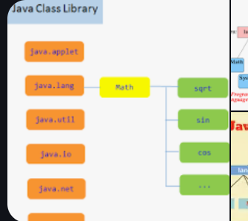

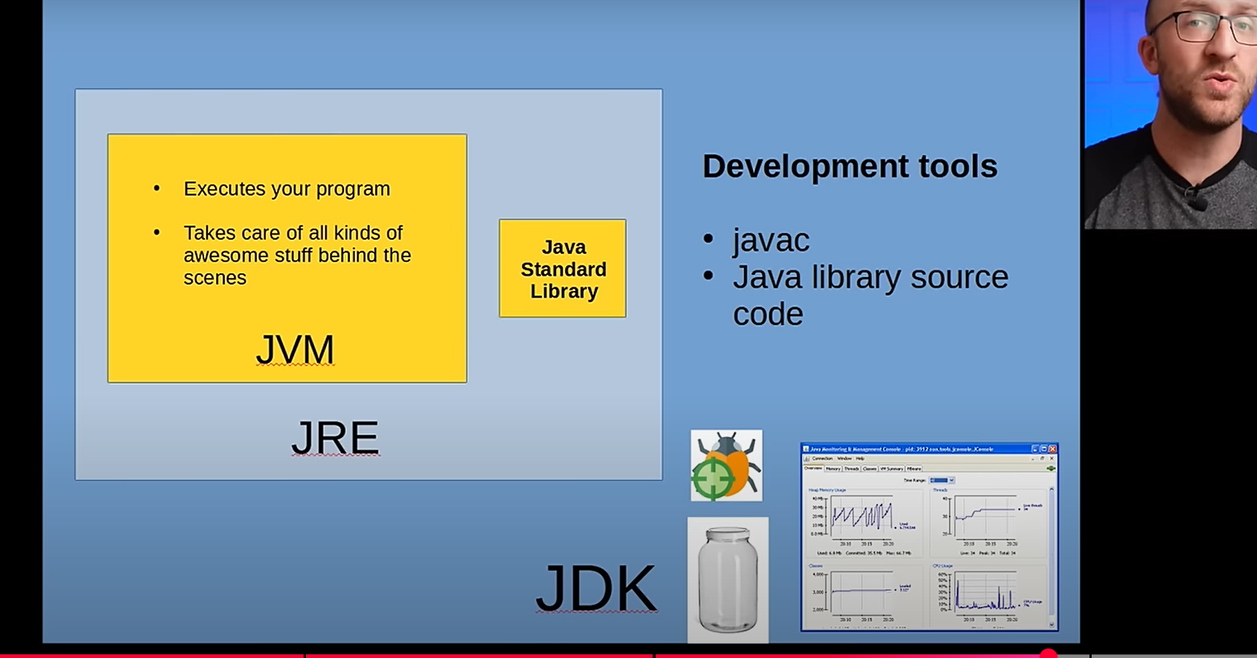

JVM takes our code class files and java standard library class files, loads them into memory and then executes them